From
THE BIG SIR SAYS...
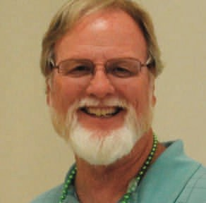thinking of inviting a friend to a SIR
SE“ OURNMISSIION OIS TO IRMPROVE THE LIVES OF OTUR MEIMBMERS THREOUGHS
FUN ACTIVITIES AND EVENTS WHILE MAKING FRIENDS FOR LIFE”
October 2019 Newsletter - Turlock Branch 143

Mark Taylor

Wow.!! What a great improvement in at- tendance at our September monthly meeting. From 71
members present in August, too close to 100 and September! It was really good to see some of the members who have not attended in a while. Thanks to Kevin and Ted who made numerous reminder phone calls. Non attendance costs us all. From the loss of money in our gen- eral fund to the waste of a uneaten food, the costs can be substantial. Therefore, it is imperative that all SIR members make it a priority to attend the monthly meetings. I am looking forward to seeing another packed house on October the 16th. Finally, a reminder that the end of the year is coming up and if you were
meeting this would be a great time. I
am sure they will enjoy the free lunch as well as the camaraderie and activities offered at SIR.
See you in October.

DEADLINE FOR THE OCTOBER NEWSLETTER IS:

PORTUGUESE ROAST BEEF
Salad with fixin’s, Rolls, Dessert, plus all the usual suspects
LUNCH MENU for OCTOBER
NOVEMBER 1-2 and 3

Personalized Hats and Shirts Coming
At our next meeting, please look for Rick Kindle…He has samples of our new SIR Hats and Shirts that are personalized for our Branch 143… The hats are $15 each and the shirts are $25.. You can purchase the limited supply of samples and put in your Order if we run out… These are produced locally here in Denair by Russell Steeley, son of our member Bob Steeley..
If you have a shirt, vest or coat that you want to put on the SIR Logo, Russel will do this for $10.00… You can call him at 209-922-8832. Show pride in your SIR Branch!!

Ladies Day Coming December 18th
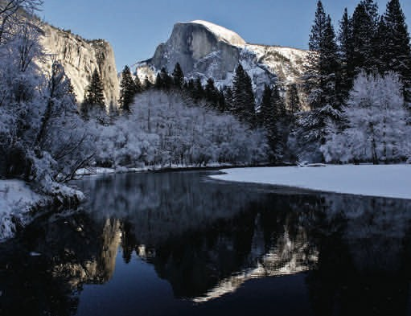On Ladies Day we will be Raffling off one of Fred Courter’s Beautiful Gallery
Wrap prints on canvas. It is of a Reflection of Half Dome taken in winter. You’ll want to be here for this one.

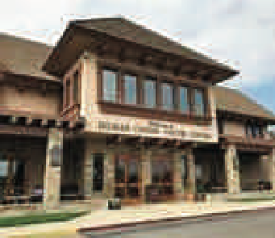Our Speaker for the month of October, will be Denise Skidmore of Hilmar Cheese Co.

Denise Skidmore started her career in dairy as a Mobile Dairy Classroom instructor with the Dairy Council of California taking a live cow and calf to elementary school to conduct assem- blies about dairy farming and milk production. After 9 years of being the “cow lady,” she joined Hilmar Cheese Company and became the “cheese lady.” Denise serves as the Director of Edu- cation and Public Relations and oversees the visitor center, public communication and sustain- ability. She has been with the company for 19 years.

Presentation will include:

- Brief history of Hilmar Cheese Company, Inc.

- Where the company is today

- Innovation and products for the future

PROGRAMS FOR THE REMAINDER OF THE YEAR
Nov. Don Smith Turlock Fruit.
Dec. Judy Kindle, Sierra Vista

Our SIR 143 Web page was finally brought up to date but could still use some help…Many members do not know it even exists… if you have time I suggest you open it up and look around…. Click on:
http://www.sirinc2.org/branch143/
Save under your favorites or put it on your main page…. If you have a prospective member and give them an invitation card, tell them the web page address is on the card and they can find out more about what we do on it… I apologize for some of the pictures of the new members and we are working to improve them. In the future, if you have pictures of SIR ac- tivities, please get them to either Fred Courter or Larry Hughes…

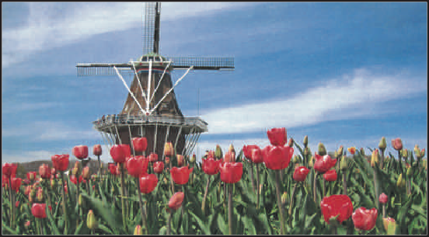
August 29-
SIR TRAVEL
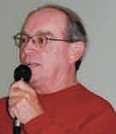BILL STIRES TRAVEL CHAIRMAN

Air Fare to be determined in Oct. 2019. Price includes all transportation, hotels, gratuities for tour manager, and more.

September 9, 2020 Switzerland, Austria, and Germany. Stay in Oberammergau,
Germany for the Passion
Play

(only performed once every 10 years,
performed since 1634)
The play is a staging of Jesus' passion, covering the short final period of his life from
his visit to Jerusalem and leading to his execution by crucifixion.
$500.00 deposit per person holds spot.
Final payment not due until March 1, 2020

11 days that includes airfare, transfers, hotels, some meals,
along with tour guide and bus driver.

SIR Area 18, and Friends Presents*
A Holiday Celebration!
Reno Overnight Tour December 11-12, 2019
TOUR INCLUSIONS:
Deluxe Storer Coachways Motorcoach Transportation Coffee & donuts will be provided morning of depar- ture
Accommodations at the Eldorado Hotel & Casino, Reno
Private Group Cocktail Party + Dinner Buffet Santa’s Christmas Extravaganza at the Eldorado Show Room

Price: Approximately $5700 per person.
(Continued on page 5)

If interested in any trips call Bill at home phone 209-544-2684, cell phone 209-988-5445 or email bstires46@gmail.com
to receive a reservation form.
Friends, neighbors and relatives can go on any of the SIR trips.

SIR TRAVEL Continued from page 4

Eldorado Hotel Breakfast Buffet Coupon Free time for gambling at The Nugget Casino
$10.00 total in Casino Bonus Packages (subject to change)
Driver Gratuity
COST PER PERSON: $292.00 Per Person, Double Occupancy. $322.00 Per Person,
Single Occupancy
Full payment due upon booking Minimum of 24 pas- sengers needed by November 8, 2019 or the trip will be cancelled.

HOLLAND TULIP FESTIVAL TOUR FEATURING MACKINAC IS- LAND’S GRAND HOTEL
May 7- 14, 2020

Price: $3,365 Double Occupancy $4,415 Single Airfare price is
$249 per person has been extended to
September 15, 2019
Please RSVP to Bill at 544-2684 or 988-5445. Tour Includes:
Airfare into Chicago, returning from Detroit
Airport transfers, 2 nights in Holland Michigan, visit Tulip Gardens and a working Windmill, attend the Festival along with the Music Parade.
2 nights at the Grand Hotel, the crown jewel on Mackinac Island with horse-drawn carriage tour
A tour of the Ford factory and watch a F150 pickup truck being built
Plus optional tours and much, much more.
$40 in Mayflower Money all gratuities for Tour Guide and Bus Driver

Remember that the price will go up on September 15, 2019.
$500 deposit per person by September 15, 2019 to hold these great prices.FINAL
PAYMENT DUE ON JANUARY 15, 2020.

SIRs 143 IS IN NEED OF A CATERER
At our last meeting, Connie informed us that she will be retiring and moving at the end of December. This means we need to have a new caterer in place be- fore our January meeting. If you know or have someone in mind who would like to serve as our caterer, please have them call or text their information (name, cell number) to either:
Mark Taylor 209- 620-6013
Rock Libby 209-988-8396

Ladies Day this year will
be on December 18th
...and promises to be a great presentation featuring Judy Kindle (Sir Rick's wife). We will begin selling tickets at our October and November meetings. Sir Larry Hughs will have the tickets numbered and ready and Sir Doug Brinkley will be in charge of sales. So, reserve your spot early by bringing your checkbook or wallet to the next meeting. This will also be your last opportunity to enjoy Connie's cooking. Please keep in mind that all ticket sales must be in made advance. This means there will be NO tickets sold at the door. Also, Ladies Day is still consid- ered a regular SIR meeting and a member does not need to bring a partner in order to attend.

SIR GOLF SCHEDULE Thru DECEMBER 2019

MO DATE DAY TIME HOST COURSE GR PRIZE TOT REMARKS

Oct  ** | 7 | Mon | 9:00 SG | 144 | Creekside | $22 | $9 | $31 | Carts Optional $15
 | 14 | Mon | 8:30 SG | 164 | Dry Creek | $25 | $9 | $34 | Carts Included
 | 21 | Mon | 9:00 SG | 103 | Manteca | $35 | $9 | $44 | Carts Included
 | 28 | Mon | 9:00 SG | 143 | Atwater | $34 | $9 | $43 | Carts Included

Nov | 4 | Mon | 9:00 SG | 144 | Creekside | $22 | $9 | $31 | Carts Optional $15
 | 12 | Tue | 9:00 SG | 164 | Manteca | $35 | $9 | $44 | Carts Included
 | 18 | Mon | 9:00 SG | 103 | Micke Grove | $29 | $9 | $38 | Carts Included
 | 25 | Mon | 9:00 SG | 143 | Swenson | $18 | $9 | $27 | Carts Optional $14

Dec | 2 | Mon | 9:00 SG | 144 | Creekside | $22 | $9 | $31 | Carts Optional $15
 | 9 | Mon | 9:00 SG | 164 | Reserve | $42 | $9 | $51 | Carts Included
 | 16 | Mon | 9:00 SG | 143 | Atwater | $34 | $9 | $43 | Carts Included
“ OUR MISSION IS TO IMPROVE THE LIVES OF OUR MEMBERS THROUGH FUN ACTIVITIES AND EVENTS WHILE MAKING FRIENDS FOR LIFE”

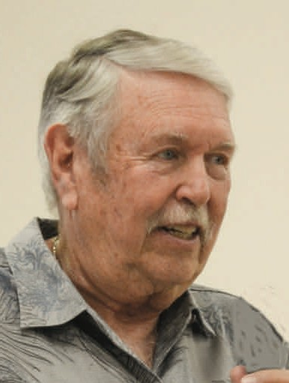I would like to thank Rick and Judy Kindle for hosting the September dinner. The
evening was a rousing success and a great time was had by all!

Please join me in supporting these programs.
Gary Toombs Activities Chairman
NEW PROGRAMS
We are starting or restarting a few new
programs for SIR members. Please con- tact the following club members and get in on the ground floor if any of these programs interest you:
CRIBBAGE: Gary Potter 667 8516

GIN RUMMEY: Ken Kajioka 209- 602-8351

PICKLEBALL: Bob Lotspeich 485 6225 (cell) or 535 1748 (home)

RC AIRPLANES: Larry Date 632 7287
or Greg Back 585 6862

PINOCHLE: Wayne Rickey 634-7644
COMMEMORTIVE AIR FORCE:
Breakfast at Hanger 1-S Modesto Air- port on 2nd Saturday of each month. Contact Gary Toombs 604-8406

CHESS: Kevin Storms ( a brand new member) 277 7644

Dine In Dine Out:

Dine In - Dine Out in November will be at Toscana’s in Turlock on Thursday, Novem- ber 21st. It will be in the banquet room just remodeled area. Cocktails 5 pm Dinner 6 pm from regular menu. (there will be a
$10.00 corkage fee for those who want to bring their own wine)
Bocce Ball:

Bocce Ball in October will be First and Third Thursdays, October 3 and 17 at the Dust Bowl from 10:00 to 12:00,
If you can, let’s have lunch at the Dust Bowl after our game. They are letting us use the courts at no charge! If you have any ques- tions call Tom Bundy at 209-668-5763

PLEASE CHECK-OUT OUR NEW CALENDAR OF EVENTS AND PROGRAMS IN THIS ISSUE

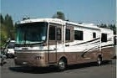
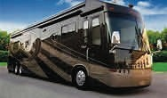
RV TRAVEL

Ken Kajioka

SIR #143 & Guests 2019 Wine Country Resort October 20th – 25th, 2019

Wagon Master, Don Nordell, 209-606-0505 Trail Boss, Ken Kajioka, 209-602-8351

TENTATIVE AGENDA SUBJECT TO CHANGE
Sunday 20th 1:00PM arrive, Get setup & meet your neighbors (Hosts) Ken & Don
5:30PM Hot dogs & makings

Monday 21st 9:00AM light breakfast (Hosts) Freddie Graham

5:30PM Pot luck dinner & Crew (A-M cold dish) (N-Z Hot Dish)

Tuesday 22nd 9:00AM breakfast (Hosts) Dave Nordell

5:00PM bring your meat to BBQ & Crew

Wednesday 23rd 9:00AM breakfast (Need a Host)

5:30PM dinner (Need a Host)

Thursday 24th On your own all day Friday 25th On your own all day (Host) Meals will be prorated
Bring your own table service to all meals

RESERVATIONS
DEPOSIT OF $60.00 PAYABLE TO: Trail Boss KEN KAJIOKA 209-602-8351
2240 Polyview Dr., Turlock, CA 95382
WE HAVE ONLY 25 SITES….SO YOUR DEPOSIT RESERVES YOUR SITE!!!
I NEED TO MAKE YOUR RESERVATION TO WINE COUNTRY RV RESORT BY AUGUST 24, 2019

SIR #143 & GUESTS 2020 JACKSON RANCHERIA RV OUTING
MARCH 29 - APRIL 3
Trail Boss: KEN KAJIOKA 209-602-8351

TENTATIVE AGENDA SUBJECT TO CHANGE
SUNDAY - Arrive 3 pm Get set up and meet your neighbors
5:30 pm HOT DOGS and FIXINGS

MONDAY - 9:00 am BREAKFAST

5:30 pm DINNER POTLUCK (A-M Hot Dish,
N-Z Cold Dish

TUESDAY - 9:00 am BREAKFAST

5:00 pm DINNER Bring your own meat

WEDNESDAY - 9:00 am BREAKFAST

5:30 pm DINNER, Spaghetti

THURSDAY - On Your Own

FRIDAY - Drive Safe - HAPPY EASTER!

People going to this event have to make their own reservations at Jackson Rancheria. Please advise Ken after making your reservation.

IF YOU KNOW ANYONE WHO HAS AN RV & Wants to Go
On Any of these events Call Ken Kajioka 209-602-8351

HAPPY
BIRTHDAY
BIRTHDAYS IN SEPTEMBER

Larry Date, Carmine DeSomma, Jim Gerdes, Ladd Hackler, Dick Johnson, Albert Litfin, Jack Patterson, Tony Romero, John Simone, Ralph Smithcamp, George Soles,
David Williams, Randall Yerby

ANNIVERSARIES IN SEPTEMBER
Kevin Byrne, Edward Friedberg, Westley Jacobs,
Albert Litfin, Paul Lytle, Bernie Mailloux, Robert Rearick,
Michael Sakaguchi Micha

BEC MINUTES

BRANCH 143 - SIR EXECUTIVE BOARD MEETING
BLACK BEAR DINER, TURLOCK SEPTEMBER 20, 2019

Attendance: Big Sir Mark Taylor, Little Sir Greg Back, Treasurer Bob Holly, Gary Toombs and Ted Thorn.
Directors: Rock Libby, Ken Kajioka, Mike Sakaguchi and Ken Edwards
Absent: Wardee Bruce, Brad Sleeper, Gary Toombs, Gary Potter

Committee Representatives Present:
Joe Adams, Golf; Kevin Byrne, Membership. Guests: Ken Vietch
Call to Order/ Welcome: 8:04 a.m. by Mark Taylor, Big Sir
Secretary’s Report: Larry Date was absent but Min- utes of last BEC meeting were approved, 1st Greg Back, 2nd Ted Thorn.
Treasurer’s Report: Bob Holly reports 100 attended our September Luncheon, including 4 prospective members. Checking balance $ $1585.75. Received check from Bill Stires for insurance for the Alaska trip and in turn Bob sent check for same amount to State SIR. There was discussion of the need to update the signature card for our bank account and it was agreed that all signors would proceed to the bank fol- lowing the BEC meeting to accomplish that. Ap- proved, 1st Gregg Back, 2nd Ken Edwards.

Committee Reports:
Kevin Byrne, Membership: Kevin reports on he and Ted Thorn’s efforts to contact 20 members not attend- ing luncheon meetings. The result was 5 members dropped per their request. We received one new ap- plication for membership from Neal (pronounced Nile) Ali. Kevin’s report and Neal’s application were ap- proved with a 1st by Rock Libby and 2nd by Joe Adams.
Joe Adams, Golf: Our final tourney including dinner is at Manteca on 9/30 and Joe has purchased gift certificates from Dick’s Sporting Goods. This is al- ways a great lunch and raffle and a good time will be had by all attending. Our new golf year starts 10/1/19 and our NCGA dues are due 1/1/20. Joe will retire from Sirs Regional Director of Golf at the end of this year. He will continue to be involved with SIR Golf.
R/C: Greg Back: Our new radio-controlled aircraft flying group is (forgive me) struggling to get off the ground and Greg expects to get started in the next week or two. Please get your name on the list or contact Greg if you are interested.
Bowling: Tony Ferro reported at our luncheon that this is the most participation he has seen in SIR Bowling since he has been involved. However our group was not allowed to relocated to Ten Pin Bowl- ing, Turlock.
Travel, Bill Stires: Bill was absent, no report
Travel R/V: Trail Boss ; Ken Kajioka discussed the new State RV Committee and Chairman. He notes there are still openings for the Paso Robles trip slated for October 20th – 25th.
Sunshine, Jack Miller: Jack again reminds us that we need to let him know if anyone is ailing so he can call, send a card or visit the member who is under the weather. He states that Jim Mann is still at Brandel and he appreciates visitors. Al Souza is at Turlock Rehabilitation and would like to see any members who have the time to drop by.
Dine in/Dine out: Gary Toombs reports a great evening at our Potluck at the home of Rick and Judy Kindle. These gracious hosts knocked it out of the park again this year. Gary points out that everyone loves the Potluck dinners BUT … each dinner re- quires a host and we need someone besides the Kin- dles to step up if we want more of them. There was mention of an idea for a Potluck Only group. We will likely have a dinner out in November.
Notes: Russ Winton is doing a fabulous job with his Wine Tasting classes and a Big Welcome Back to Larry Hughes, who will be printing the tickets for our upcoming Ladies Day.
Unfinished Business: We again discussed the need for a new Caterer to replace Connie who is retiring on 01/01/20. The Board has chosen a committee to de- termine bid specs for our caterer search. The group consists or Chairman Ken Kajioka, Gary Toombs, Mark Taylor, Mike Sakaguchi and Rock Libby. Please contact one of them with suggestions or concerns.
Money is a concern here so we discussed methods of increasing revenue.
New Business: Sir Training for new and returning of- ficers for 2020 will be held at The Elks Lodge on No- vember 5th from 9-3. The lodge is located at 645 Charity Way, Modesto.
Meeting Adjourned at: 9:09 am by Big Sir Mark Tay- lor
Respectfully submitted, Rock Libby For Larry Date, Secretary, Branch 143

A Great Time Was Had By All
At the Last Dine In Dine Out
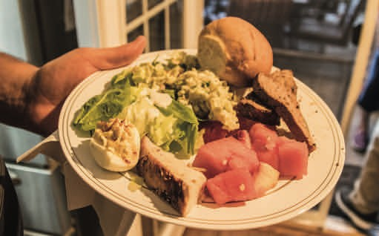

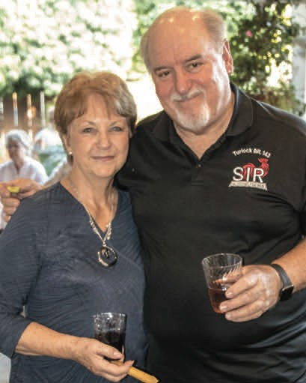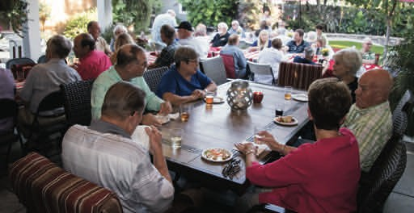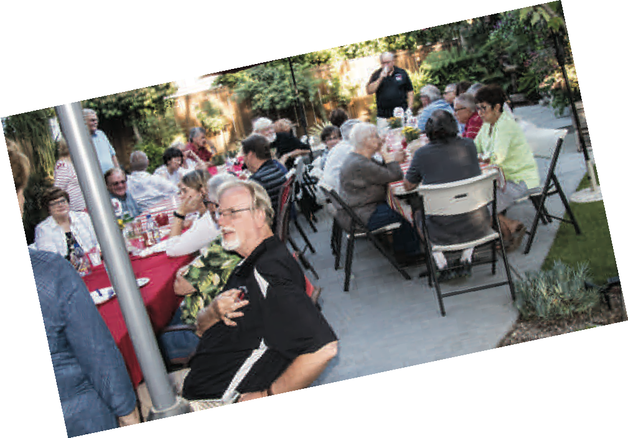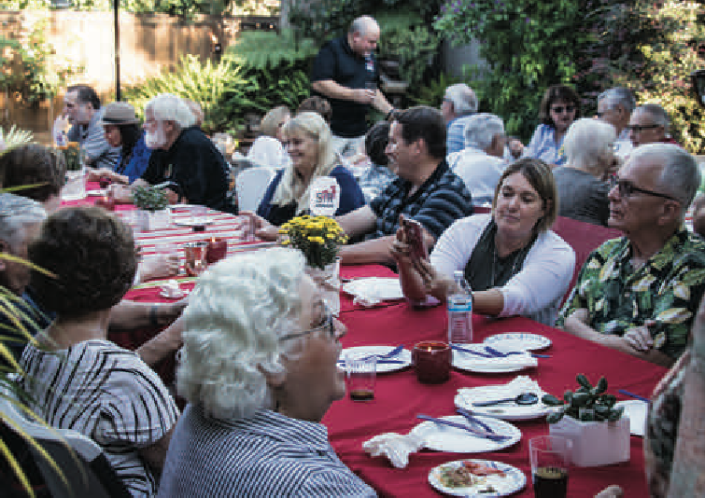Thanks Rick and Judy Kindle for hosting the September dinner. The evening was a rousing success and a great time was had by all!

SIRs BRANCH 143 ACTIVITY CALENDAR
Contact Committee Chairman for Activity Details

OCTOBER 2019
SUN | MON | TUE | WED | THU | FRI | SAT
 |  | 1 | 2 | 3  9-HOLE GOLF  Bocche Ball  10-11 am | 4 | 5
6 | 7  Pickleball 8 am | 8 | 9 | 10  9-HOLE GOLF  Pickleball 8 am | 11 | 12  Commemortive Air Force Hanger 1-S
16
Cribbage
After Meeting

Gin Rummy After Meeting

LUNCHEON 11:30 am
13 | 14  Pickleball 8 am | 15 |  | Bocche 17  Ball  10-11 am  9-HOLE GOLF  Pickleball 8 am | 18 | 19
20 | 21  Pickleball 8 am | 22 |  | 24  9-HOLE GOLF  Pickleball 8 am | 25 | 26
 |  |  | 23
27 | 28  Pickleball 8 am | 29 | 30 | 31  9-HOLE GOLF  Pickleball 8 am
PRINT THIS PAGE OR CUT IT OUT AND PUT IT ON YOUR FRIDGE AS A REMINDER ABOUT THE ACTIVITIES OF SIRs

Page 12 Sons In Retirement - Turlock Branch 143 OCTOBER 2019

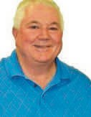WINE TASTING

Russ Winton

Wine Investigation for Novices and Oenophiles (W.I.N.O)

SIR members,
There will be no WINO tastings in Octo- ber, sorry, my dance card is full. Here are a few local bargain wine buys; the 2016 Wagon Train Red Wine from Yolo County and the 2014 Turnpress Deep Dark Red Wine from Paso Robles, each $4.95 at the local Grocery Outlet. They tied for First Place in a blind tasting of five Red Blends from the G.O. and all were under $5. The 2016 Columbia Crest Cabernet Sauvignon is under $7 in most supermarkets.
It is my go to Cab for an inexpensive house red and I usually go to Safeway for their 6-pak
prices. Also Costco still has the Marietta's OVR for $9.95 and had a close-out sale on Steel's Mendocino Zinfandel for under $10, both great buys. One of the best Roses' i've had this year is the 2018 Alexander Valley Vineyard's Rose' of Sangiovese. Retail is $16 but sale priced in a six-pak is under $12. If you love Yosemite but never go because of the crowds and you'r a true WINO, consider going in November to the Vintners' Holidays at the Ahwahnee Hotel. Check out travelyosemite.com for more infor- mation or just ask me. Cheers!

JUST FOR LAUGHS
IF YOU CANNOT MAKE A LUNCHEON PLEASE CALL
Kevin Byrne, Membership Chairman…648-2374

TURLOCK BRANCH NO. 143 OFFICERS AND CHAIRMEN OFFICERS FOR 2019

Big Sir Mark Taylor | 620-6013
Little Sir Greg Back | 585-6862
Secretary Larry Date | 634-6508
Assistant Secretary Tom Baldwin | 668-2483
Treasurer Bob Holly | 668-2786
Assistant Treasurer Mike Sakaguchi | 602-5740
Membership Kevin Bryne | 648-2373
Assistant Membership Ted Thorne | 874-2249
Recruiting Wardee Bruce | 634-6304
Bowling Tony Ferro | 634-8377
Travel Bill Stires | 544-2684
Roster/Mailing Brad Sleeper | 620-2620
Golf Joe Adams | 632-8197
Assistant Golf Ray Walker | 606-9889
Sunshine Jack Miller | 632-4294
Newsletter Editor/Photographer Fred Courter | 226-1173
Bocce Ball Gary Toombs | 604-8406
Program Gary Potter | 667-8516
Assistant Program Ernie Peters | 581-3187
Catering/Hall Set-Up Earl Hamilton | 632-1101
Wagon Master Don Nordell | 606-0505
Trail Boss KenKajioka | 667-6588
Dine-In ~ Dine-Out Gary Toombs | 604-8406
Nominating Committee Chair Gary Toombs | 604-8406
Directors Gary Toombs, Wardee Bruce, Larry Date, (one Open Positions) Ken Kajioka, Rock Libby

STATE OFFICERS
State President: Ed Benson - 925-943-7011 Regional Director: Rick Kindle - 652-8608 Area 18 Governor: Patrick Reed - 289-3314

